# Evidence of effective / appropriate project management (Agile, SCRUM, SCRUMBAN, Kanban, etc.)

Currently we follow the Agile development practice of using Sprints. Every sprint cycle is typically one week long. Every Friday we allocate work for each team member, and they have until the next Friday to complete this work. These short cycles ensure that work is produced quickly, and that everyone is constantly working on the project, rather than people being given a month and waiting until last minute to start working. Every day the team leader checks in on the other team member’s progress in case there are any challenges. You can check the meeting_minutes folder on Gitlab to see what work a team member has been assigned.

We meet with our project sponsor at the beginning of every month, where we present our work so far. By meeting frequently, we ensure that we are on the right track and are meeting the requirements of our sponsor.

The challenges of this methodology are making sure that the work allocated is reasonable given the amount of time. This can be especially challenging as different team members work at different speeds or have different commitments during the sprint that mean they can’t be expected to produce a high quantity of work. As such there has to be some flexibility regarding the work assigned.

# Documentation of sprints / retrospectives / workload management / formal meetings (where applicable)

The minutes of our formal meetings are stored on our GitLab repository in the ‘Meeting_Minutes’ folder. This folder is divided into months so that you can find the relevant minutes for each month, Other relevant files are also included in the folder that demonstrate the work we did that week that wasn’t code related.

The minutes were written by Kejia and Nicole and follow a consistent format to make them easy to understand. They begin with what the aim of that conference was, who attended and what work was allocated.

# Use of project management tools (Trello / Microsoft Planner / Teams / Slack)

Our team has tried a few different project management tools, but currently we use Microsoft Teams to store files that we can all edit together. Originally we used OneDrive to store our files, but Microsoft Teams offers more features as you can send messages to each other, schedule meetings on the calendar, and add channels to the group.

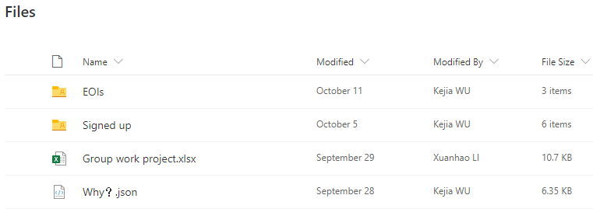

Our original OneDrive folder

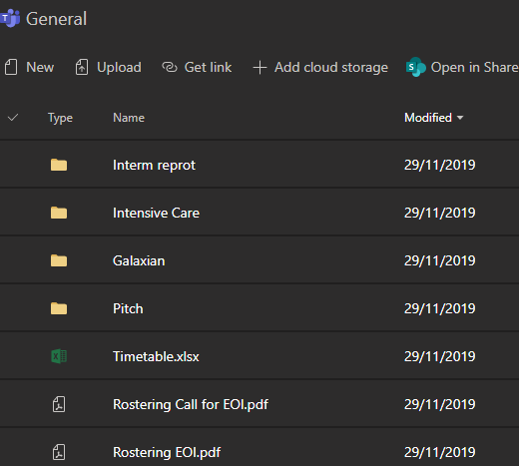

Team 35 on Microsoft Teams

Our team normally uses a WhatsApp group chat for discussion, or emailing for more formal communication. Our sponsor has requested we use Zoom to host video conferences with her.

# Effective use of team skills / skills transfers / cross training

We have all studied web development last year, so we all had some experience with HTML, PHP, CSS and JavaScript to create websites. It therefore made sense to use them, rather than learning a new programming language like C++.

Since Xuanhao hadn’t used Git before this project, the other team members, including the Git Master Gurjyot, assisted him so that he could push to the project. He can now use Git successfully and has made 11 commits to the master branch so far.

Because Kejia has created a Hotel Management system before, he has experience making a calendar which displays each month. He was in charge of the timetabling view which shows what employees are assigned to roles each month, since his previous project mean he had more expertise in these features.

|  |  |
| --- | --- |
| Kejia's Hotel Management System, homepage | *Kejia's Hotel Management System, calendar* |

Gurjyot has the most experience in art and design, so she has been producing the frontend login system where she can focus on the GUI and using stylesheets. When the components are combined, she will ensure that the pages all follow a consistent and clean design.

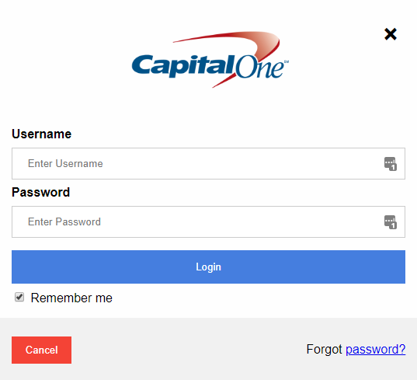

The login GUI produced by Gurjyot

# Professional attitude / disciplined / consistent / timely / punctual / autonomous & self-organising

Our team always meets on every Friday between 2-4pm. Sometimes our team also meets at other points during the week, especially if a few team members must work with each other on something.